**Lesson 9 Demo 8**

**Troubleshooting Networking Issues**



Steps to be followed:

1. Finding a pod’s cluster IP
2. Finding a service’s IP
3. Fetching a container’s PID
4. Tracking connection

**Step 1: Finding a Pod’s Cluster IP**

1. Execute the following command to find a pod’s cluster IP:

***kubectl get pod -o wide***

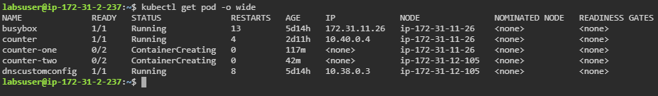

**Step 2: Finding a Service’s IP**

1. Execute the following command to obtain the IP address of all the services:

***kubectl get svc -o wide***

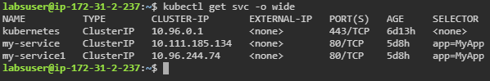

**Step 3:** **Fetching a Container’s PID**

1. Fetch the PID of a container using the following command:

***docker inspect --format ‘{{ .State.Pid }}’ 892e80b83a6***



**Step 4: Tracking Connection**

1. Execute the following command to list all the connections in the container:

***sudo conntrack -L***

